# Create An account on IOTappStory.com

Go to IOTappStory.com

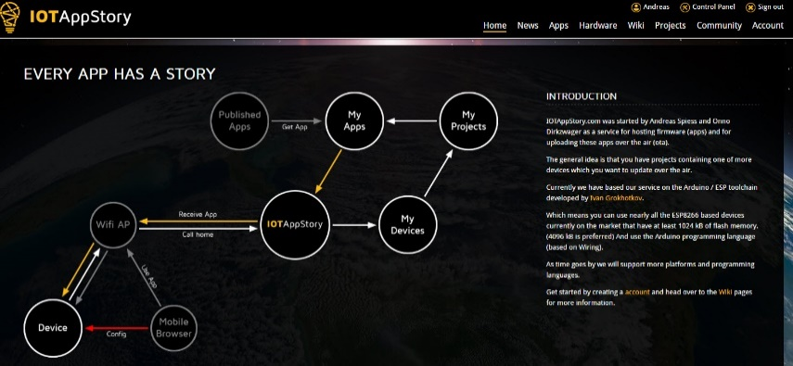

Go to Account

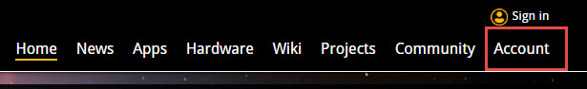 and “Create Account”

Enter your data:

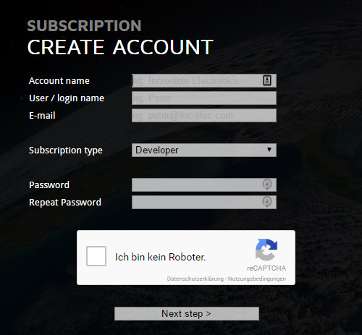

You get a confirmation:

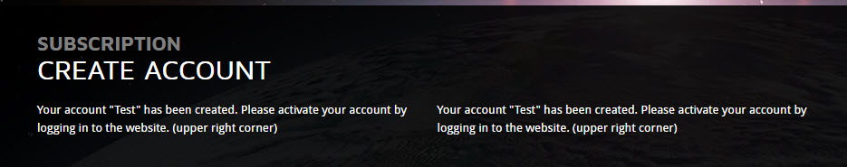

Now, you can log-in

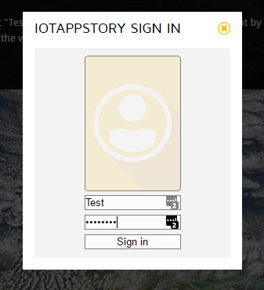

And edit your settings:

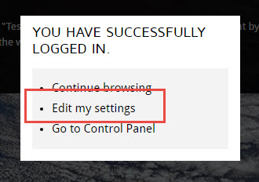

Please fill-in the needed fields. We love a real picture of you!

Now you are done and can continue with setting up your project.